Client.py Program:

This program sends the message of “Hello” over the UDP protocol on one port and waits to hear the echo of the message on another port.

Sample execution:

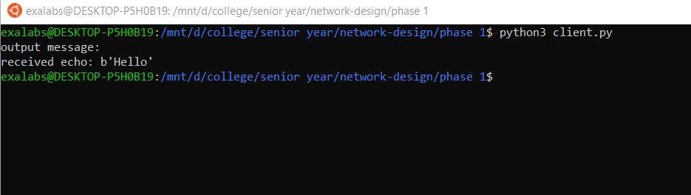

server.py Program:

This program waits to receive the message of “Hello” over the UDP protocol and then echos this over another port.

Sample execution:

